**Second Year Computing**

**Web Development and Practical Databases**

**CSS Exercises**

**Lab Sheet 2 - Solutions**

**Completion date: 5/11/2021**

**Exercise 1**

Create at least two divs that each include an image of your choice and enough text (any text) to precede the images, flow around them (one on the left and one on the right), and continue after the image.

Use borders, padding and margins to see the effects of them.

**E1.html**

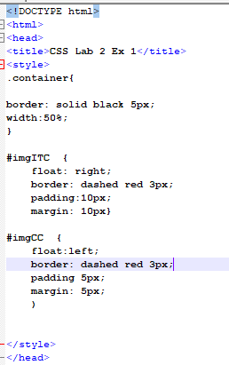

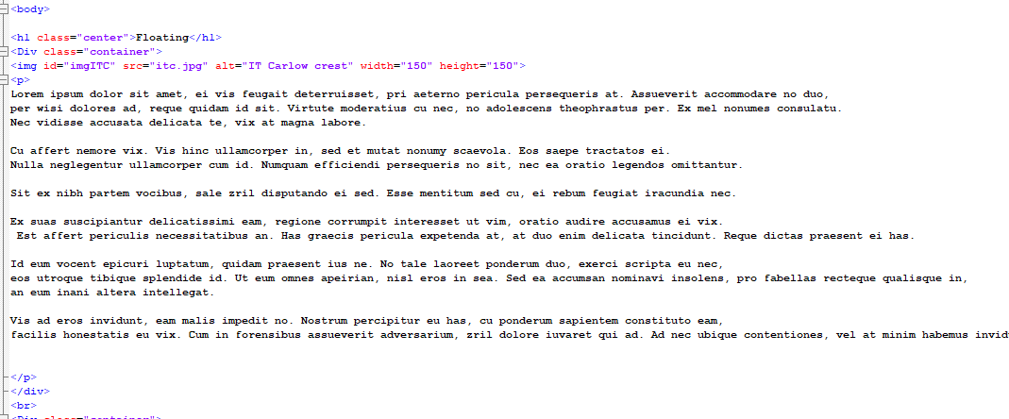

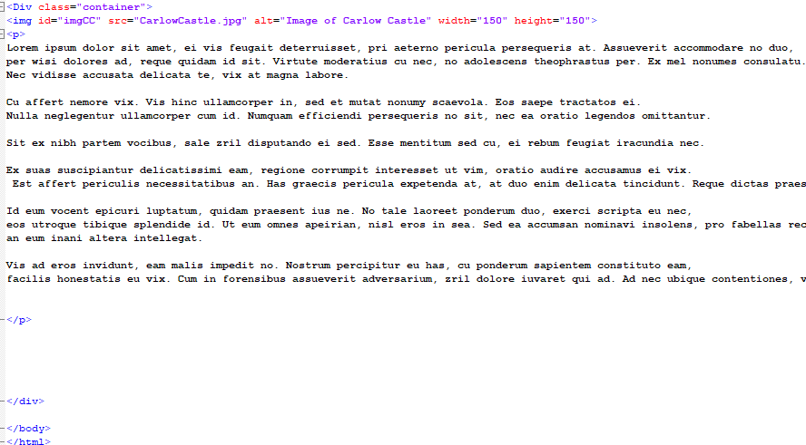

**Exercise 2**

Write the html and CSS to fix a footer at the bottom of the web page. When you scroll, the footer should stay in position.

The footer should have some white text in the centre and a red background the full width of the page. It should be an appropriate height.

**Ex2.html*****Note that you need enough text in the div to see the effect of the fixed positioning.***

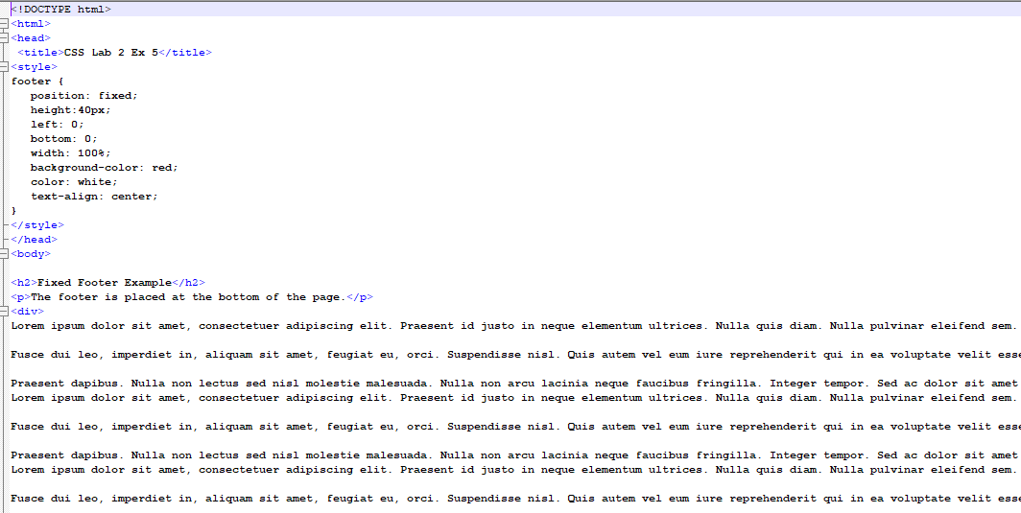

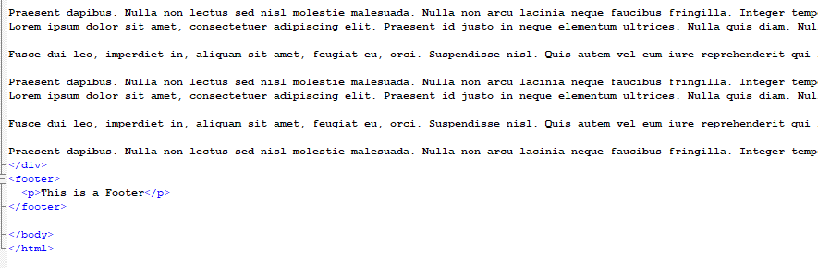

**Exercise 3**

Write the html and CSS to position three boxes vertically on the web page.

The boxes can be 100px X 100px each a different colour, and with a different border.

**Notes**: No positioning needed.

Use the box-sizing property to ensure that the boxes remain the same size even they have different size borders.

Ex3.html

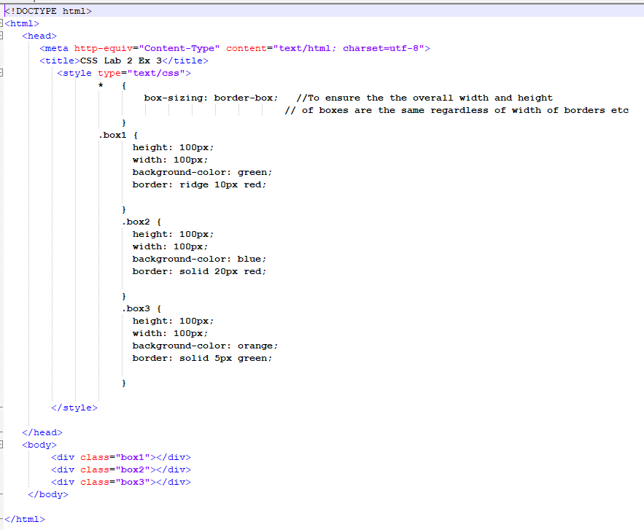

**Exercise 4**

Use **relative positioning** to change the position of each of the boxes in Exercise 6.

* Move the first box by 25px from the top and in 30px from the left.
* Move the second box 50% down the page from the top and 25% in from the left.
* Move the third box up by 25px and in 30px from the right.

**Ex4.html**

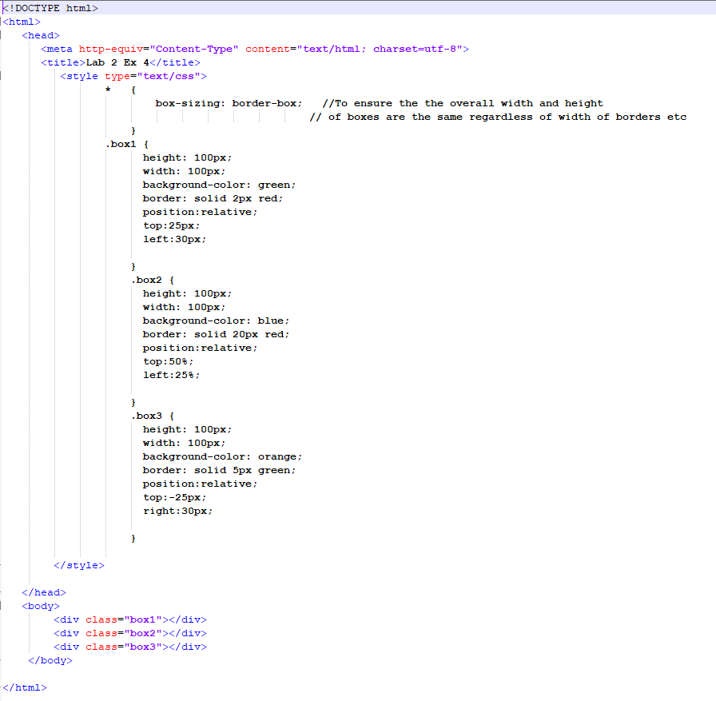

**Exercise 5**

Use absolute positioning to move boxes in Exercise 6 to specific locations page.

* Position the first box to the bottom of the page, and 40px in from the right.
* Position the second box at the top of the page near the right.
* Position the third box up 25px above the top of the page and 30px in from the right.

Note the overlapping of the elements on the page, and the order of the overlapping.

**Ex5.html**

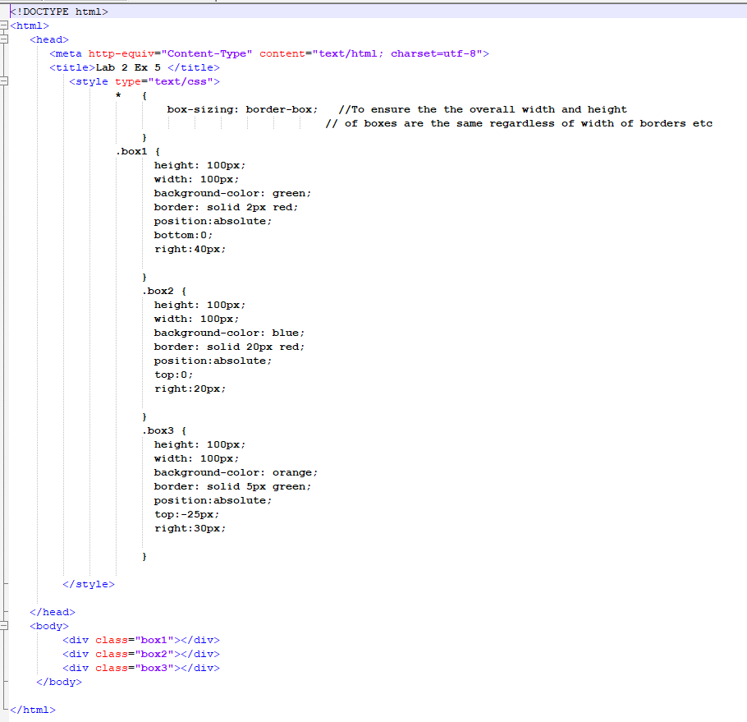

**Exercise 6**

Using the following html markup:

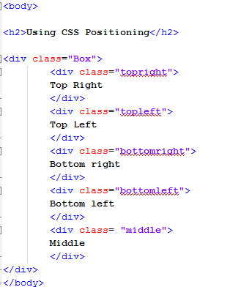

Write the CSS rules to ensure that the result looks like the following image:

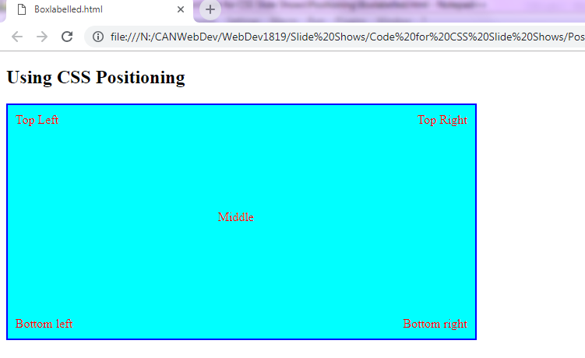Note: You will need to use the position property.

**Ex6.html**

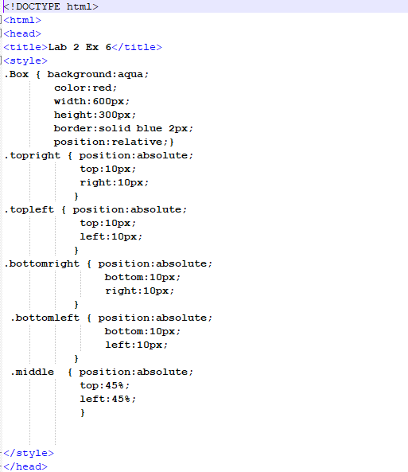

**Exercise 7**

Display on a web page the royal flush in order, one overlapping the previous one.

The image files for the cards in a royal flush – 10, Jack, Queen, King and Ace of Diamonds are on blackboard - Images for cards are on Blackboard with the lab sheet.

**Note**: In order to use the z-index, you must use relative or absolute positioning on the elements.

Put the images in a random order in the html to see the effect of the positioning.

The result should look something like this:

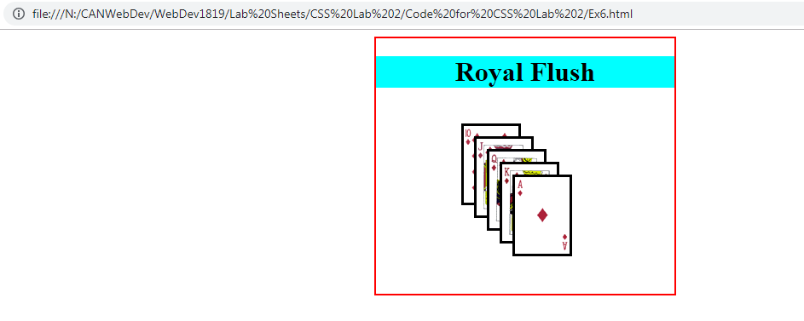

**Ex7.css**

Note that the wrapper has a position:relative to allow the absolute positioning within the wrapper. 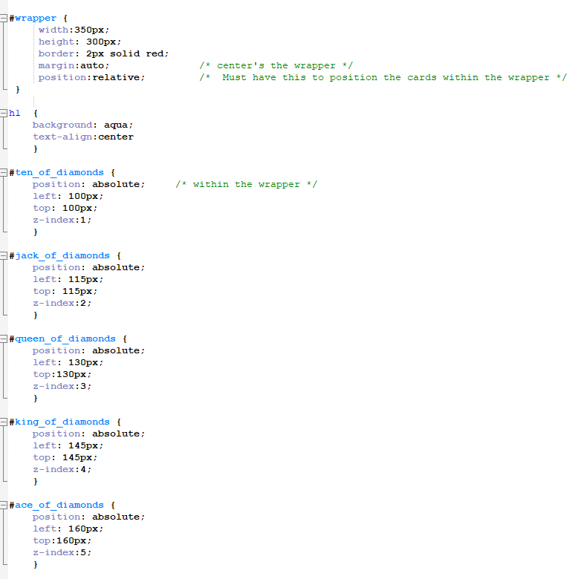

**Ex7.html**

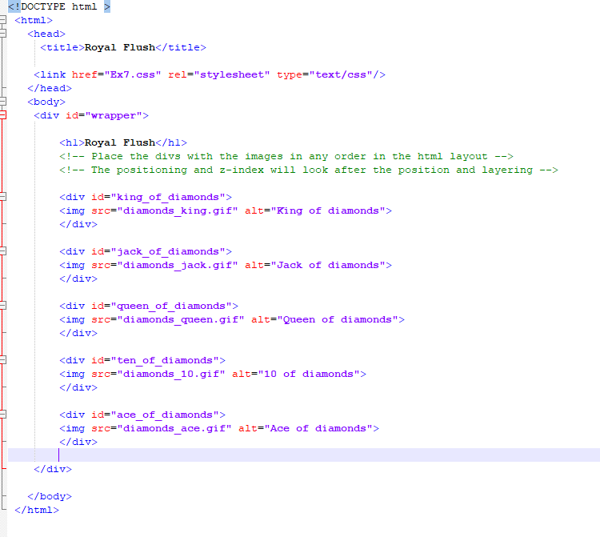

**Exercise 8(Optional)** This is optional, so I didn’t include my code.

Use the CSS position property to create a webpage that looks like the one below.

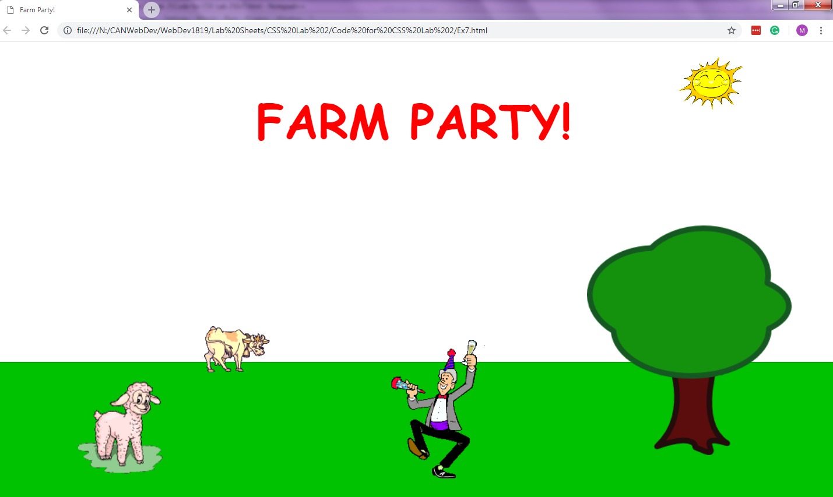

Here are recommended steps for making this happen:

* Create a blank web page with just html, head, body, and a style tag.
* Change the background of the page to be a sky blue and have a background image of clouds.
* Create a div for the grass - position it at the bottom and give it an appropriate height.
* Create a div for the "Farm Party!" banner - position it near the top centre area, and style the text so that it's red. For a bonus, use a fun custom font like from Google Web Fonts.
* For each of the images shown, search for an appropriate image on Google Image search - it doesn't have to be exactly the same. Try searches like "sheep animated gif" and if you need to, restrict the results to just "clip art". When you find the image, create a img for it on the page.
* Position each of the img elements appropriately. The sheep should be around the bottom left, the cow should be on the horizon, the man should be dancing in the middle, the tree should be on the front right, and the sun should be around the upper right.
* As a bonus, position a picture of your face on top of the man, and watch yourself have a farm party!

*Save your exercise files on M/WebDev/CSS Exercises/lab 2/ E8.html, and E8.css (If you used it)*